1.git config –global user.name “Rishikesh”
2. git config –global user.email “Rishikesh@gmail.com”
3.git config (used to show the user name and detail)
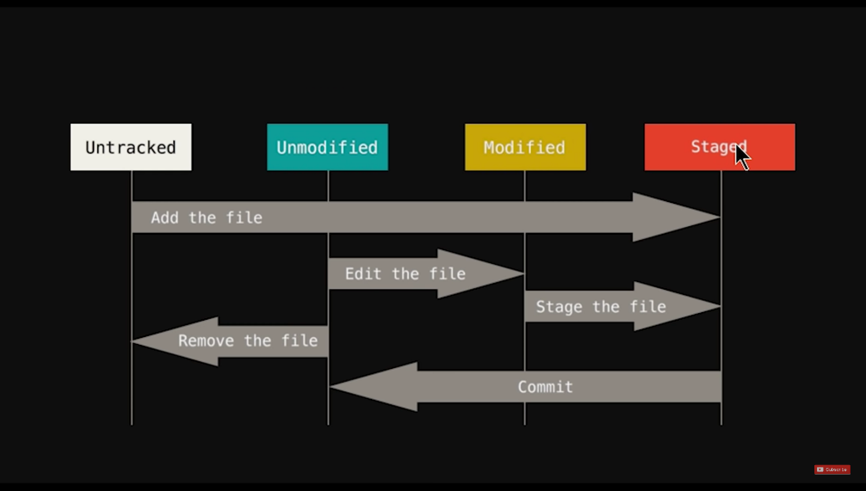
4.git init
5.git status
6.touch filename. Extension
7.git add filename. Extension
8.git add -A
9.git commit -m “Message”
10.git checkout filename. Extension
11.git checkout -f (get all the file to its previous commit)
12 git log (All history of commit)
13git log -p -2(All history upto 2 previous commit)
14.git rm filename. Extension(remove file)
15.git rm –cached(remove only from staged area not from HDD)
15.git diff (diff between current working directory with staged area)
16.git diff –staged(diff between last commit and staged area)
17.git commit -a -m “Message” (skip staged area and directly to commit)

